1. Install AZ for windows

<https://docs.microsoft.com/en-us/cli/azure/install-azure-cli-windows?view=azure-cli-latest>

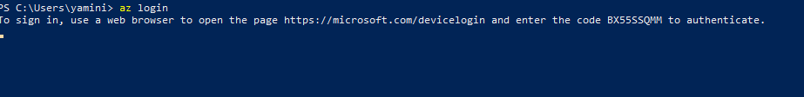

1. Az login to login to azure

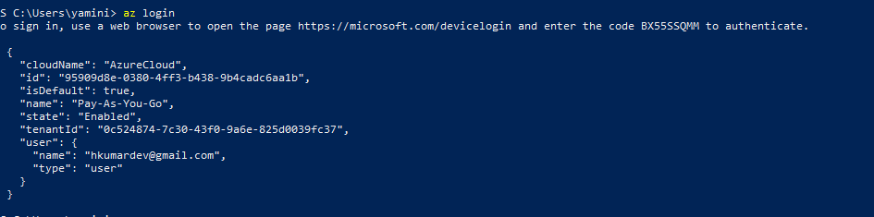

1. Install Azure RM to manage azure resources

Note: Be an admin to powershell

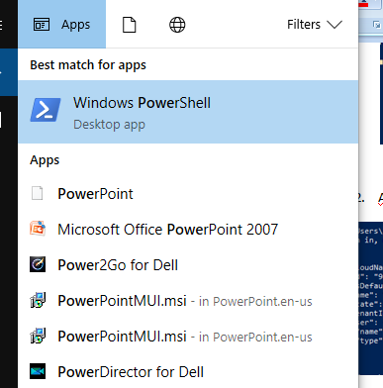

1. start-Transcript
2. Get-ExecutionPolicy
3. Set-ExecutionPolicy RemoteSigned
4. Install-Module azureRM
5. Install-Module azure – AllowClobber

Then you can manage powershell scripts

1. Inorder to connect azure rm

Create an service principal with subscription, tenant (azure ad) id.

For ex:

az ad sp create-for-rbac --name myapp --password PASSWORD

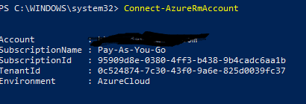

1. Now we can create resource group automation as well as many other resources

Creating new resource group: abc4

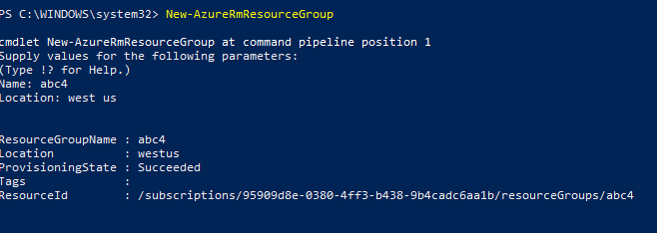

1. Check the portal to see its created:

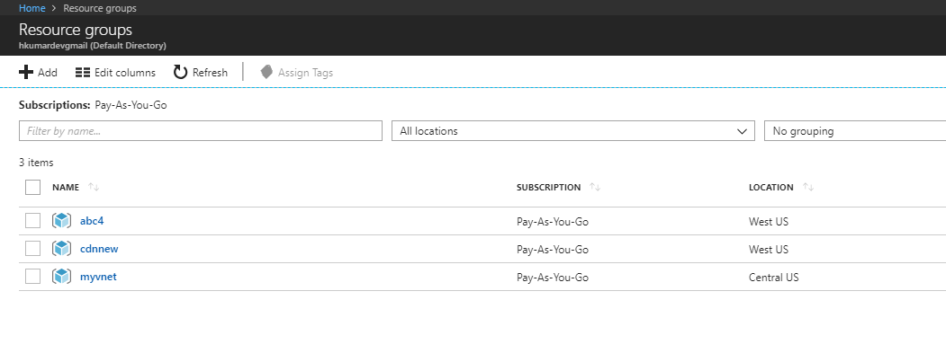

1. For Azure App service:

Connect-AzureRmAccount

Start-AzureRmwebAppSlot -ResourceGroupName “ azurevmgroup” –Name “ azurevm1” – slot “dev1”

We can create powershell script and execute it and saving as ps1.